**RESEARCH DOCUMENTATION**

This document presents the outcome of our research into existing mobile apps that has functionalities close to what we are currently building. We have thoroughly searched into the app stores to see if there could be any existing features that we can incorporate into our app project, and although there exist no app that directly does the same task, but we found some cool features that we can implement to also make the app a better one.

Some of these features may not be implemented immediately, but we wanted to document them should in case the need arises. Some of the apps and the features of interest are documented below:

1. **Know Your Rights App – By UNICEF Innovations Lab for Kosovo**



**Source:** https://play.google.com/store/apps/details?id=org.knowyourrights.knowyourrights&hl=en_CA

**About the App**

Know Your Rights is an online platform which provides youth friendly descriptions of rights that young people (aged 16-29) are entitled to by applicable legislation in Kosovo. It covers some of the main rights in the areas of education, health, minority communities, employment, family, contact with the law, community engagement, social benefits and youth empowerment. The descriptions of the rights are accompanied by a mapping of the institutions that are responsible to uphold the rights, as well as those to which young people can address complaints if the rights are violated.

The platform also contains a section detailing the process of how to address complaints to the Ombudsperson Institution in Kosovo (OIK) and provides an opportunity to file cases directly through the Know Your Rights platform. As the administrator of the platform, UNICEF Innovations Lab guarantees the anonymity of the case filing process through the platform. Nevertheless, it waives any responsibility regarding case management after a complaint has been filed, as this is the sole legal responsibility of the OIK. Persons who file a complaint through the Know Your Rights platforms should receive an automated confirmation of receipt from OIK and should only contact the later if there any questions regarding the case.

**Features of Interest**

1. **2. 3.**

* **Landing Page Arrangement (Image 1):** Presence of few buttons (four) on the landing page
* **Sectional Navigation (Image 3) –** A click into a section displays the subsection in a grid layout with specific content shown with images, proceeding from a list view of the section’s immediate content.

1. **Know Your Rights App – By KRC (Korean Resource Center)**



**Source:**

https://play.google.com/store/apps/details?id=org.nakasec.knowyourrights&hl=en_CA

**About the App**

Protect yourself and learn your basic rights. This app informs immigrants (documented or undocumented) about their basic rights and proper responses to law enforcement. You can also call hotline numbers in English, Korean, and Spanish.

**Features of Interest**

**

1. **2. 3. 4.**
2. **Pop Up Asking user to allow phone to make phone calls if the need arise** - We found this to be a useful feature as the user can be allowed if he/she would want the app to be able to make calls directly when the need arises.
3. **A landing page that gives users very brief information about their rights** – This could also be useful to newly landed immigrants who as at the time is oblivious of their rights or whether they have one.
4. **A wonderful feature allowing the user to get help with the click of a button without having to save or write down the number for calling.**
5. **Finally a page showing some text that can be read to a workplace oppressor or someone carrying out the abuse** – This is also helpful as the app user is expected to be a low English user, they can therefore read out this content when faced with violence of any kind.

**3. FindHello – Refugees & Immigrant Services by USAHello**



**Source:**

**https://play.google.com/store/apps/details?id=com.therefugeecenter.findhello&hl=en_CA**

**About the App**

FindHello helps refugees, immigrants and asylees settle in the United States. Search maps and links that list reliable services just for you. Find a job, lawyer, healthcare, ESL classes to learn English and more. FindHello is partnered with the UN Refugee Agency (UNHCR) to help refugees, immigrants, and those seeking asylum in the USA. FindHello connects you with everything you and your family need to feel comfortable and safe in the US. Immigrant from Mexico or refugee from Syria? FindHello will support you as you make your new life in the United States of America no matter where you come from or why you are in America.

**Features of Interest**

1. 2. 3.
2. **Multi-Language Features** – This can be a great feature for future improvement since the targeted users are people with low English usage.
3. **Offline Content** – We found this feature also useful in other not to limit the usage of the app to only online contents. It would be needed in the case of emergencies.
4. **Ability to find other resources of need.**
5. **The Ontario Infrastructure Health and Safety Association App (ON Const OHS)**

**Navigation Bar**

Retrieved from: <https://play.google.com/store/apps/details?id=ca.ihsa.construction>

This app uses a navigation bar which works by allowing users navigate into any section of the app without going back to home page as common in most mobile apps. We found this important for our app as it satisfies one of the target features of the proposed app – Ease of use. We also find this interesting navigation bar that could be used to separate the content in each section. The feature could be seen in the image below;

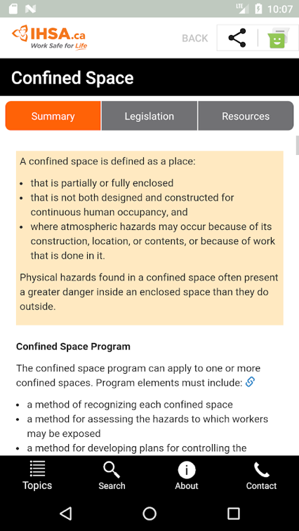

1. **GeoPro Work Alone Safety App – by Roadpost Inc.**

Retrieved from : <https://www.geoprosolutions.com/en-ca/>

Features:

**Large Buttons and Icons**

The way the Buttons and Icons are displayed are very easy to understand, even a person with low English proficiency can easily understand the layout.

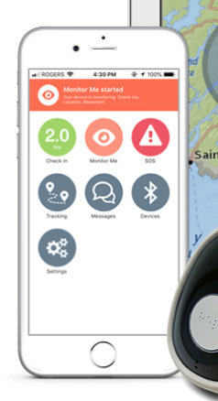 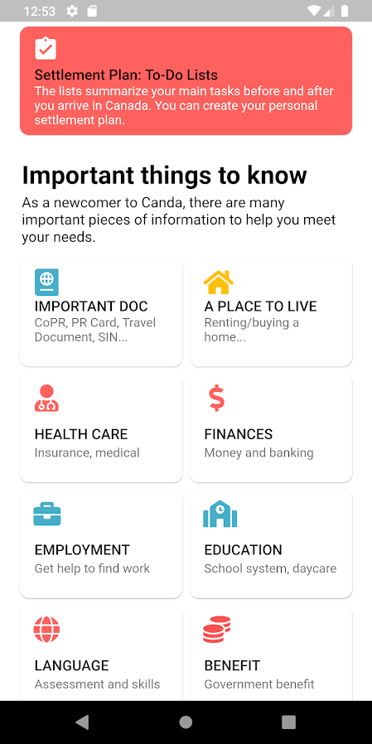

1. **JSA Cloud App – by Safety Tech:**

Retrieved from: <https://www.superiorglove.com/blog/top-apps-for-the-safety-professional>

We find this feature very important as if someone face any problem he/she can report that incident and can get timely help.

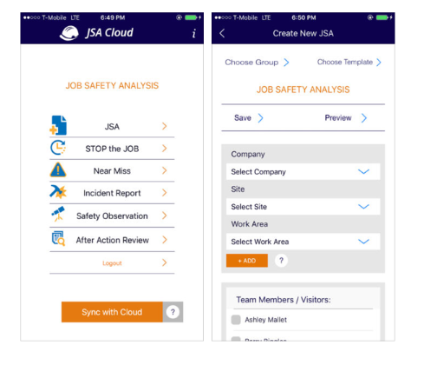

1. **The Trello App:**

Offline Mode Feature

Retrieved from: <https://yalantis.com/blog/offline-mode-application/>

We find this feature to be one of the most important aspect of this application. In case of no-internet a person can still find helpful information from the app by using in offline mode.

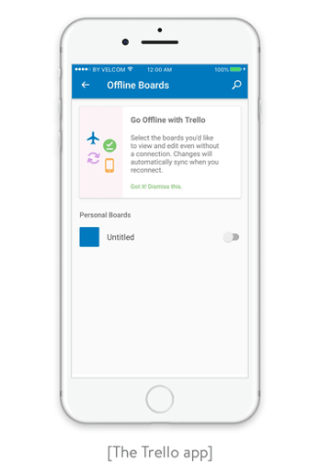

1. **Multi-Lingual Feature**

Retrieved from: <https://developer.android.com/training/basics/supporting-devices/languages>

We think that this feature can increase the usage around the globe as language plays an important role. A person can change the language he/she is comfortable in and can understand what to do in tough situations in an easy manner.

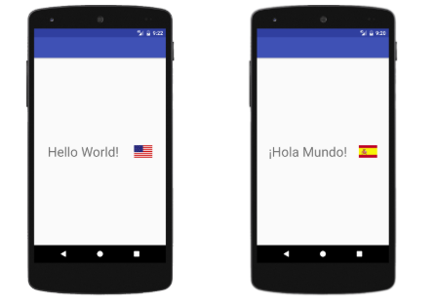

1. **Feedback Feature**

Retrieved from: <https://www.apptamin.com/blog/getting-feedback/>

We think this feature plays an important role in improving an app quality and functionality. So, adding this feature will let the development team know that where this app is lacking and there would be an immediate action on things that needs to be improve.

